Felicia Permenter, FNP Bio

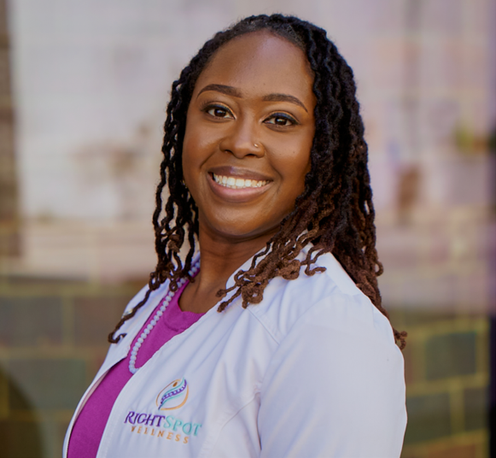

Nurse Felicia’s path began in critical care, where she witnessed both the resilience and fragility of the human body. Determined to help people before crisis, she moved into functional and integrative medicine. Blending science, compassion, and whole-person care to help patients heal at the root.

Her philosophy is simple and human: your body tells a story, and she’s here to listen. Felicia meets people where they are and partners with them on realistic, respectful plans that lead to sustainable change. Whether it’s chronic fatigue, hormonal shifts, or simply wanting to feel like yourself again, she goes beyond the labs to pursue true vitality, not just “normal” ranges.

